**M2C Final Model Test**

**Helen Kim**

**Model Overview**

Each user’s list will be assigned a unique ID and several restaurants. For the sake of the model test, a small portion of the data stored is dealt with – only the restaurant name, city, and type is logged in the database and the user is limited to one list. Ultimately, the user will be able to create as many lists as they wish and each list will contain restaurant information obtained from the Yelp API. Each of these lists will be assigned a unique ID, a name, and optional tags to allow the user to filter search through their lists.

**Working Demo**

*Due to issues with connecting to mongod when the server was deployed, I used NS to show source files. I was unable to get the Now URL working properly. Both are included for reference.*

Now URL: <https://restaurantappfinalproject-axmsnwplpi.now.sh/>

NS URL: <https://ns-zartvjelqv.now.sh>

*Adding a Restaurant (two were created in this demo)*

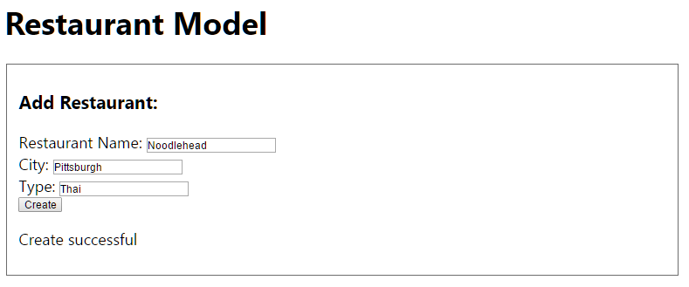

*Finding a Restaurant using its name*

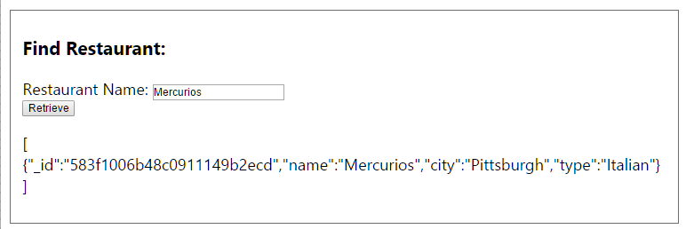

*Updating a Restaurant and seeing the changes*

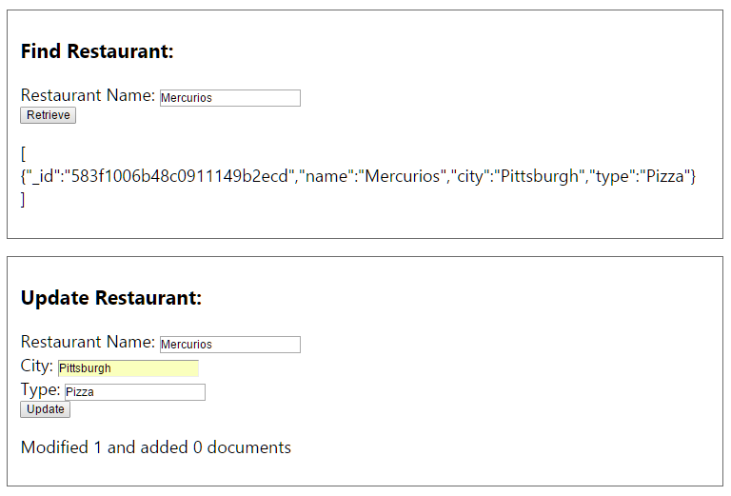

*Deleting a Restaurant and seeing it is gone from collection*



